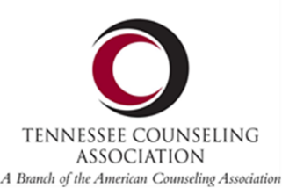 | TACES  Tennessee Association for Counselor Education and Supervision  GRADUATE STUDENT POSTER APPLICATION
(Note: Presenters must be graduate students at the time of the conference and can be listed as the primary presenter on only one application.)

Presenter(s) Full Name(s):

Contact Emails & Phone Numbers for each presenter:

Program of Study (check one): ☐ Doctoral or ☐ Master’s

Identify Concentration/Area of Study:

University affiliation:

Title of Presentation (limit 80 characters including spaces):

Program summary: In 50 words or less, clearly and accurately describe your presentation. Use complete sentences, proper grammar and correct spelling as this description may be used in the conference program. Be sure to submit a typed application (rather than a handwritten copy).
Click here to enter text

Poster Type (check one): ☐ Research Study in progress ☐ Research Study completed
☐ Literature Review ☐ Intervention/Technique

Eligible poster presentations must be relevant to the counseling profession and may include the following:
- Completed literature review  - Qualitative studies that can be described in a research format  - Master’s thesis  - Doctoral dissertation | - Counseling interventions or techniques  - Independent research project  - Completed empirical studies that have research format (show introduction, lit review, method, results, and brief discussion)

First place winner of the poster presentation will receive $100! Don’t miss this opportunity!

If approved, I agree to (initial next to each statement):
Register for the conference as a student (Note: you will qualify for the student discount rather than the presenter discount)
Provide my own poster easel (Note: easels and tables are not provided by the hotel/TCA)
Be a TCA member at the time of the conference
Be present to display the poster at the TCA conference in Nashville (Saturday, November 12, 2022 – 2:30 p.m. until 3:15 p.m.) Note: prepare to arrive prior to start time for set-up
Attend the poster awards session immediately following the presentation. Winners must be present to accept awards.

Please return this completed form to: tca19posters@tcacounselors.org with the subject line “TACES 2022 Grad Posters” by Friday, October 21, 2022.

